|  |  |
| --- | --- |
|  | **YEAR 12 MATHEMATICS SPECIALIST**  **SEMESTER ONE 2016**  **TEST 1: Complex Numbers** |

Name: _______________________

Thursday 3rd March

**Time: 55 minutes Mark /45 = %**

* Answer all questions neatly in the spaces provided. **Show all working.**
* You are permitted to use the Formula Sheet in **both** sections of the test.
* You are permitted one A4 page (one side) of notes in the calculator assumed section.

**Calculator free section Suggested time: 30 minutes /25**

1. [7 marks]

A complex polynomial  is defined by .

When  is divided by , there is a remainder of .

* 1. Show that 

[2]

* 1. Use synthetic substitution to evaluate 

[2]

* 1. Determine all solutions to 

[2]

* 1. Write  as a product of linear factors

[1]

1. [6 marks – 1 each]

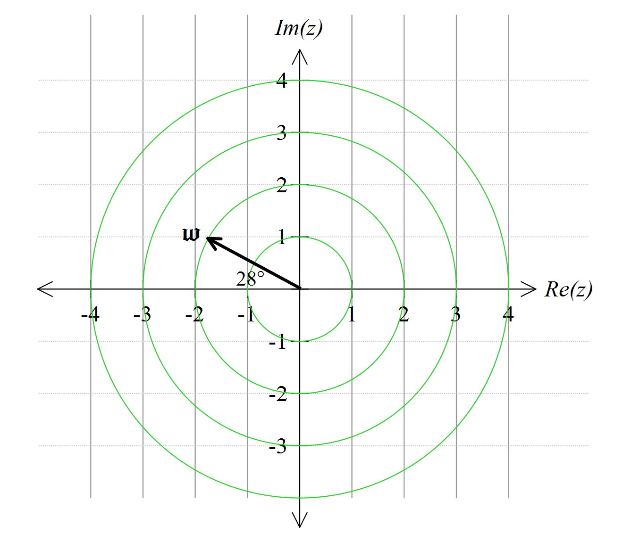

A complex number  is defined by the vector shown.

Add these vectors to the diagram:

* 1. 
  2. 
  3. 
  4. 
  5. 
  6. 

1. 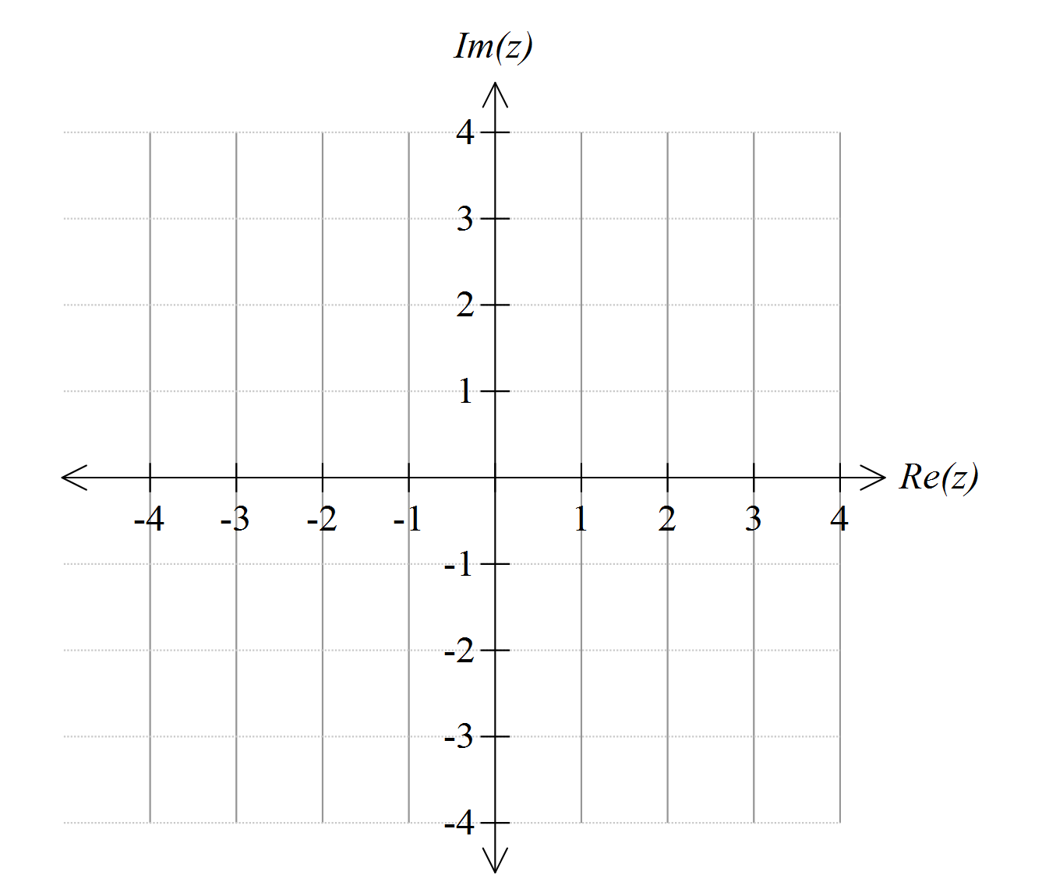[4 marks – 2 each]
   1. Sketch the region which satisfies the inequality 
   2. This region can also be represented by an inequality of the form . What are the values of *a* and *b*?
2. [4 marks]

Determine all solutions to .

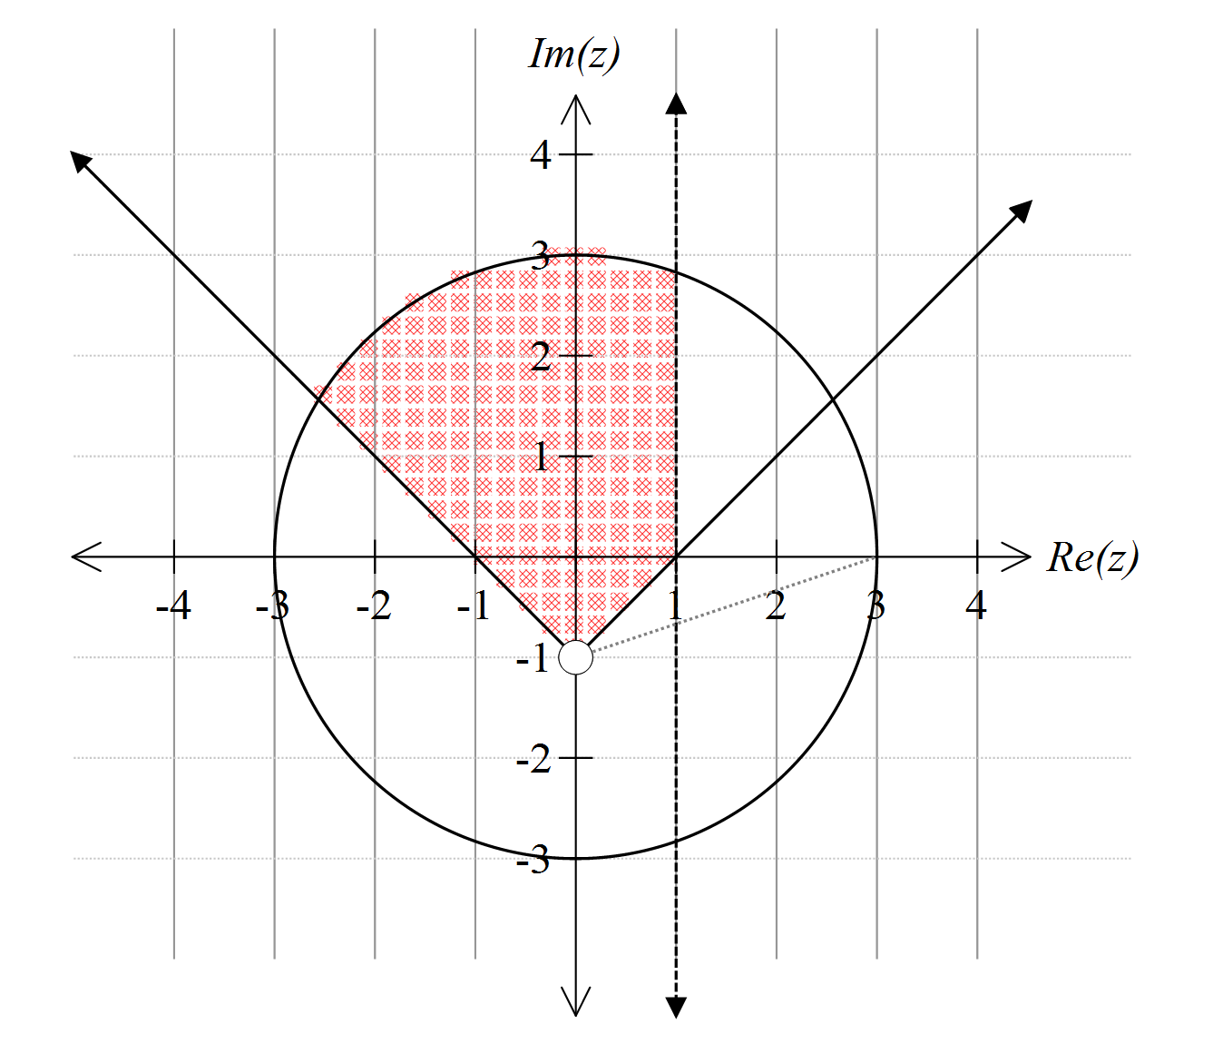

1. [4 marks]

Write inequalities needed to define the shaded region:

**Calculator assumed section Suggested time: 25 minutes /20**

Name: _______________________

1. [8 marks]

Complex numbers  are defined by and .

* 1. Write  in polar (cis) form

[1]

* 1. Convert  to rectangular form

[1]

* 1. Calculate in polar form

[2]

* 1. Calculate  in both polar and rectangular forms

[2]

* 1. Show clearly how to use your result in (d) to find an exact value for 

[2]

1. [5 marks]

Identify the centre and the radius of the circle in the complex plane with equation 

1. [7 marks]

Two complex numbers  are defined by and .

On this Argand diagram, *P* represents *z*, *Q* is the product , *R* is  and *M* the mid-point of *QR*

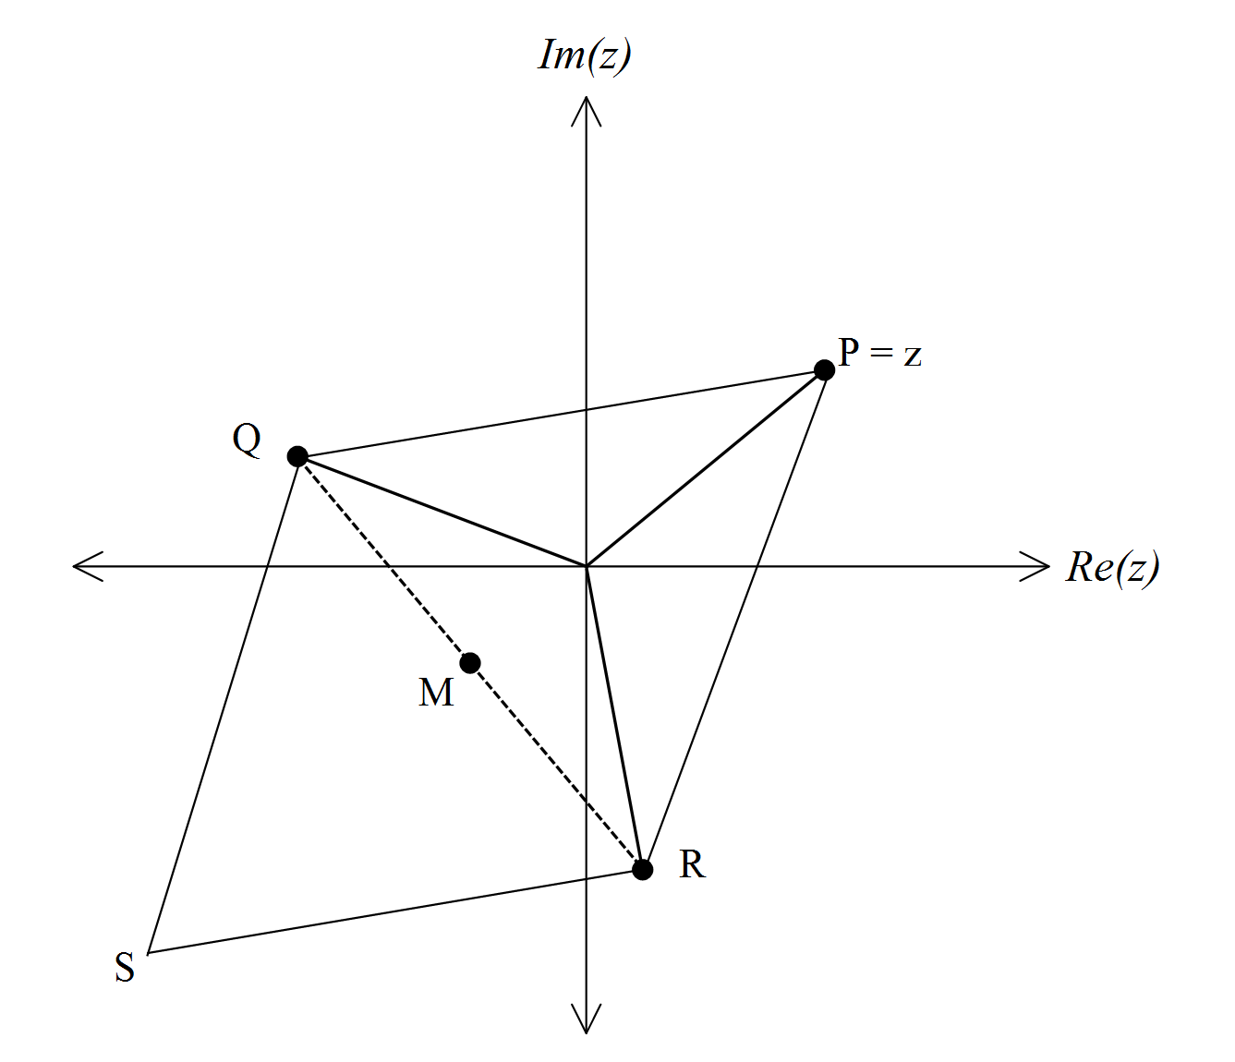

* 1. Write  and in polar form

[2]

* 1. Evaluate  and hence, or otherwise, show that *M* represents the complex number 

[3]

* 1. *S* is chosen so that *QPRS* is a parallelogram. Which number is represented by *S*?

[2]